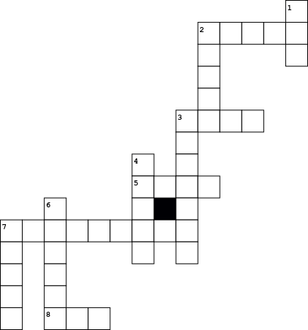

|  |  |  |  |  |  |  |
| --- | --- | --- | --- | --- | --- | --- |
| **Across** | | | **Down** | | | |
| **2.** |  | **1.** | |  | **7.** |  | |
| **3.** |  | **2.** | |  |  |  | |
| **5.** |  | **3.** | |  |  |  | |
| **7.** |  | **4.** | |  |  |  | |
| **8.** |  | **6.** | |  |  |  | |